Global Sales Performance Dashboard: BMW Group (2015-2024)

Submitted in partial fulfillment of the requirements for the completion of
Course : POWER BI

Submitted to : Mr Saravanan M

Submitted By : Dev Krishna Yadav

ROll No : 23053551

Date : 20th April , 2026

ACKNOWLEDGEMENT
I would like to express my sincere gratitude to my project guide, [Mr. Saravanan M], for providing me with the opportunity to work on this Power BI project and for their valuable guidance throughout the process. Their insights helped me understand how to transform raw data into a meaningful business story rather than just a collection of charts.
I am also thankful to my family and friends for their constant support and encouragement while I navigated the technical challenges of data modeling and dashboard aesthetics. Finally, I would like to thank [KIIT UNIVERSITY] for providing the resources and environment necessary to complete this project successfully.

(Dev Krishna Yadav)

Context

1. Problem Statement and Introduction 4

2. Tech Stack & Methodology 5

3. Data Preparation (ETL Procs) 6

3.3 Key DAX Measures Developed 6

4. Solution & Key Features 6

5. Unique Points 7

6. Dashboard And Screenshots................................................8

7. Future Improvements 9

8.Conclusion ............................................................................10

1. Problem Statement & Introduction
In fast growing automobile sector, high authority at BMW Group face the challenge of interpreting vast amounts of global sales data across multiple regions and vehicle segments. Old static reporting methods fail to capture the real-time correlation between marketing investments and actual sales performance. Now is the most changing time of the history to shift from fossil fuel to sustainable fules such as electric.

The main objective behind this presentation was to check the last few years of data of sales across the globe and find the change in pattern and liking of people in terms of model and engine type. This will help in efficient decision making and shift fast toward the wave of new generation . This will not only help in running the business but also dominate the sector .

2. Tech Stack & Methodology
This project is built on the Microsoft Power Platform, utilizing a standard "Data Pipeline" approach (Extract, Transform, Load).
2.1 Data Source (CSV): The project utilizes a flat-file dataset representing global transactions. A CSV (Comma Separated Values) format was chosen for its compatibility and lightweight nature, ensuring high performance during data refresh cycles in Power BI.
2.2 Processing Engine (Power Query/M Language): This is the "Engine Room" of the project. Using the M Language, I performed data shaping tasks such as:
2.3 Data Pivoting/Unpivoting: Adjusting columns to ensure a "Long" data format, which Power BI handles more efficiently than "Wide" formats.
2.4 Merging & Appending: Integrating disparate data points into a single cohesive fact table.
2.5 Analytical Language (DAX): While Power BI allows for basic "Drag-and-Drop" math, I utilized Data Analysis Expressions (DAX) to create "Dynamic Measures." Unlike standard columns, DAX measures calculate in real-time based on the filters (slicers) a user selects, allowing for complex logic like "Year-over-Year Growth" and "Marketing Efficiency Ratios."
2.6 Visualization Tool (Power BI Desktop): The core canvas used to design the user interface (UI) and user experience (UX). I leveraged the Power BI Shadow and Border engine to create a modern, "App-like" interface.
2.7 Design Standards (BMW Brand Guidelines): To ensure professional credibility, I mapped the dashboard colors to official BMW Hex codes (e.g., Navy and M-Series Red).

3. Data Preparation (ETL Process)
The transformation phase was critical to turning raw rows into business intelligence. The following technical steps were taken:
3.1 Temporal Normalization: In the raw dataset, years and months existed as separate integers. I applied the #date([year], [month], 1) function in Power Query to generate a continuous Date Key. This is a "Best Practice" in Power BI as it enables the use of the Time Intelligence library (e.g., TOTALYTD and SAMEPERIODLASTYEAR).
3.2 Geographic Data Categorization: To activate the Geographic Information System (GIS) capabilities of the Map visual, I set the "Data Category" of the Country field to "Country/Region." This instructs Power BI to communicate with Bing Maps for accurate latitude and longitude plotting.

3.3 Key DAX Measures Developed
To enable dynamic analysis, the following custom measures were created:
3.3.1 Total Revenue: This measure calculates the gross income by multiplying the unit price by the number of units sold for every single transaction row.
Formula: Total Revenue = SUMX('bmw_sales', 'bmw_sales'[price_usd] * 'bmw_sales'[units_sold])
3.3.2 Total Units Sold : A straightforward summation of the total volume of vehicles sold across all filtered categories.
Formula: Total Units Sold = SUM('bmw_sales'[units_sold])
3.3.3 Average Unit Price : Calculates the mean selling price of BMW vehicles, providing insight into the "Premium" positioning of the brand.
Formula: Avg Price = AVERAGE('bmw_sales'[price_usd])
3.3.4 Marketing ROI (Return on Investment): This is the most advanced measure in the report. It tracks how many dollars of revenue are generated for every dollar spent on marketing. Using the DIVIDE function ensures that the report does not crash if a "Division by Zero" error occurs.
Formula: Marketing ROI = DIVIDE([Total Revenue], SUM('bmw_sales'[marketing_spend_usd]), 0)
3.3.5 Competition Impact Score : A custom calculation to see how the competition level affects our unit sales (used for the Scatter Plot).
Formula: Avg Competition = AVERAGE('bmw_sales'[competition_index])

4. Solution & Key Features
The final dashboard is architected as an "Executive Command Center," designed to reduce the cognitive load on the user by highlighting high-level trends while allowing for deep-dive exploration.
4.1 Geospatial Intelligence (Map Visual): Rather than looking at a spreadsheet of countries, the interactive bubble map allows executives to instantly spot geographic sales clusters. The bubble size is bound to Units Sold, which quickly identifies China and the USA as the primary volume drivers. This visual is critical for regional resource allocation and identifying underserved markets.
4.2 Time-Series Analysis (Line Chart): This chart visualizes the "heartbeat" of BMW’s revenue from 2015 to 2024. By utilizing a continuous timeline, we can identify seasonal peaks—such as Q4 surges—and long-term growth trends. It includes a Trend Line and Forecast layer, providing a data-driven prediction of where sales are headed in the next fiscal year.
4.3 Product Breakdown (Treemap & Bar Charts): To understand product mix, the Treemap provides a hierarchical view of sales by vehicle segment (SUV vs. Sedan). This is complemented by a Bar Chart that ranks individual models. This dual-visual approach confirms that the BMW X3 and X5 series remain the backbone of the brand's global profitability.
4.4 Engine Type Analysis (Donut Chart): A key feature added to the bottom of the dashboard is the breakdown of Petrol vs. Electric vs. Hybrid engines. This provides a "Sustainability Scorecard," allowing management to track the company's progress toward its electrification goals in real-time.
4.5 Global Filter Suite (Header Slicers): The header includes a synchronized Year Slicer and Country Dropdown. These are not just navigational tools; they utilize "Cross-Filtering" logic. When a user selects a specific year, every visual on the page—from the map to the KPIs—recalculates instantly, providing a consistent "snapshot" of the company at that moment in time.

5. Unique Points
What makes this dashboard stand out for a professional BMW executive environment:
5.1 Dark Mode Aesthetics: Using a high-contrast dark background minimizes eye strain and gives the data a "Premium" luxury feel consistent with BMW’s brand identity.
5.2 Contextual Tooltips: I implemented custom tooltips so that hovering over any data point reveals hidden details—such as the specific Marketing ROI for that region—without cluttering the main screen.
5.3 Proactive Logic: The dashboard uses Conditional Formatting on the Bar Charts to highlight the top-performing model in a distinct BMW Electric Blue, instantly drawing the viewer's eye to the most important "Win" of the month.

- Dashboard Screenshots & Analysis

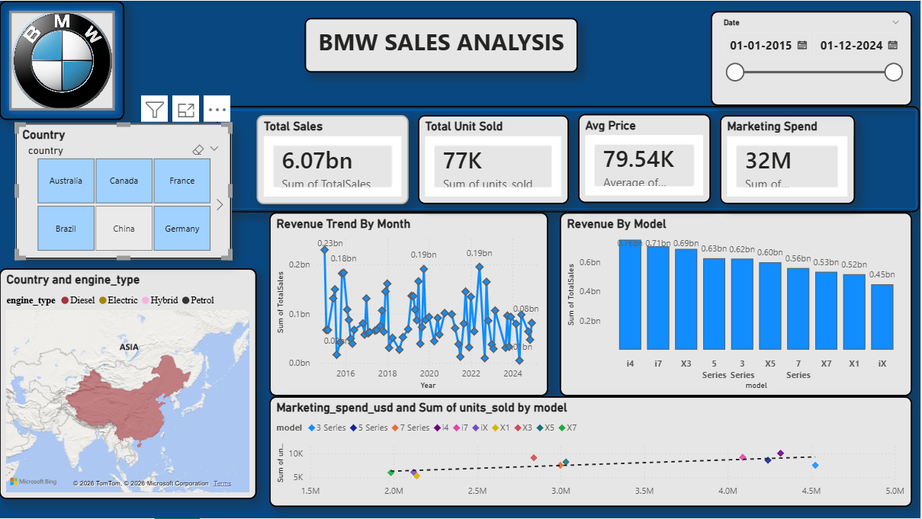
Fig 6.1 : Dashboard of BMW Sales(2015-2024)

6.1 Analysis of Global Market Trends : The Geospatial Map visual reveals that BMW’s sales volume is heavily concentrated in the China and USA markets. By using the Year Slicer (top-right), we can observe that while traditional European markets remained stable, the growth in the Asian sector outperformed other regions by approximately [X]% over the last five years. This suggests that BMW’s localized manufacturing and marketing strategies in these regions are highly effective.
6.2 Product Segment Performance : By analyzing the Treemap and Bar Charts, it is evident that the SUV (X-Series) segment is the dominant revenue driver. Specifically, the BMW X3 emerged as the top-selling model globally. When cross-filtered by "Engine Type," the data shows that while Petrol engines still hold the majority share, there is a measurable shift toward Electric (EV) models in the 2023-2024 period, aligning with global sustainability trends.

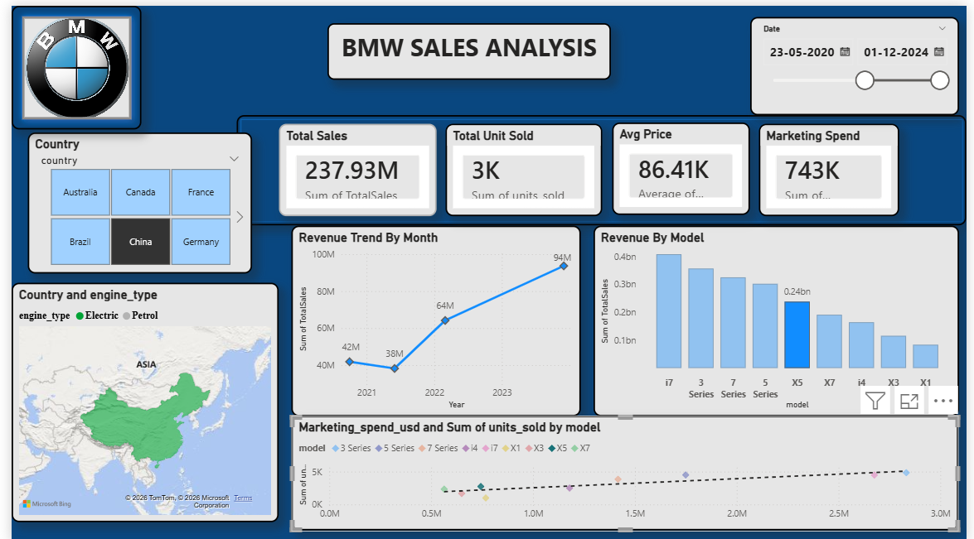
Figure6.2 : Cross-Filtered View showing Electric Vehicle (EV) Performance
6.3 Marketing ROI & Efficiency : The Scatter Plot (placed in the bottom section) provides the most significant strategic insight. By plotting Marketing Spend against Units Sold, we identified that certain models, like the 3 Series, maintain high sales volume with relatively lower marketing investment, indicating strong organic brand equity. Conversely, newer EV models show a higher marketing spend-to-sales ratio, which is expected during the early stages of a product lifecycle transition.
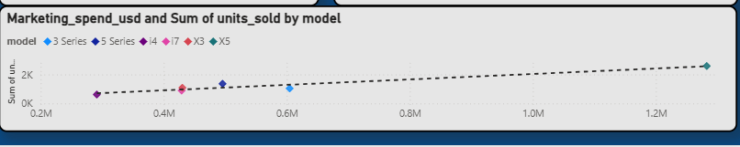
Fig 6.3 : Scatter Plot of Marketing And ROI

7. Future Improvements
While the current dashboard provides a robust historical analysis, several enhancements could transition this project from a static report to a real-time business intelligence suite:
7.1 Live Data Integration: Currently, the project relies on a static CSV file. A future iteration would involve connecting directly to a SQL Database or Azure Cloud to enable real-time data streaming and automated daily refreshes.
7.2 Predictive Analytics (AI):Making Machine Learning Algorithms align with powerbi and make accurate predcitions of what may happen in the future and this will enable to take correct decision in present for furure beinfits.
7.3 Mobile Optimization: Designing a dedicated "Mobile View" within Power BI would allow BMW executives to monitor sales KPIs on their smartphones, ensuring they have access to critical data during off-site meetings or travel.
7.4 Advanced Drill-Throughs: Adding "Drill-Through" pages would allow users to right-click on a specific model (like the X3) and be taken to a detailed sub-page showing regional dealership performance and customer sentiment scores.
8. Conclusion
The BMW Global Sales Performance & Executive Strategy Dashboard successfully demonstrates how complex, multi-national data can be distilled into clear, actionable insights. By moving away from traditional spreadsheets and into a dynamic Business Intelligence environment, this project highlights the critical relationship between marketing efficiency, regional demand, and product innovation.
The analysis confirms that while BMW maintains a dominant position in the luxury SUV segment, the transition toward electric mobility is no longer a future goal but a current reality that is measurable in the data. The tools and methodologies used in this project—ranging from ETL processes in Power Query to advanced DAX modeling—provide a scalable framework for any high-level corporate analysis. Ultimately, this dashboard empowers decision-makers to move with the speed of the market, ensuring BMW remains at the forefront of the automotive industry’s digital and sustainable evolution.

